CONNECTED, LEVEL 2 2014, How Do You Know?  Pop! Froth! Fizz!  by Rex Bartholomew  Overview  The class in this graphic story investigate acid-carbonate reactions. The students make predictions and observe what happens. At the end of the text, they suggest a possible explanation.  A Google Slides version of this article is available at www.connected.tki.org.nz. |  |  | 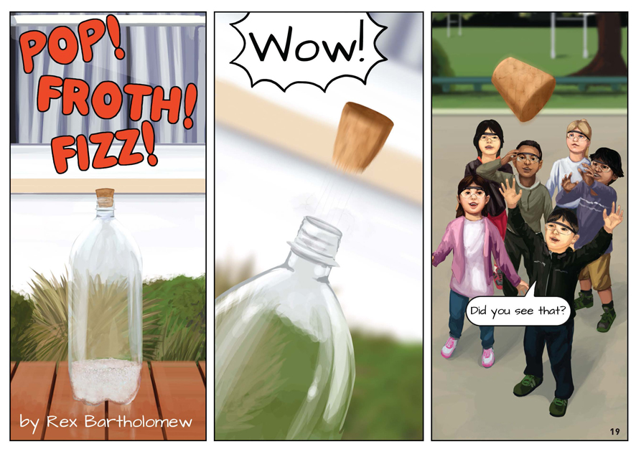
Science capability: Use evidence |  | Text characteristics

Science is a way of explaining the world. Science is empirical and measurable. This means that in science, explanations need to be supported by evidence that is based on, or derived from, observations of the natural world. Students should be encouraged to support their ideas with evidence and look for evidence that supports or contradicts other explanations.  At the core of science is theory building – making better explanations. What sets scientific explanations apart from other ways of explaining the world is their reliance on evidence and their ability to evolve as new evidence comes to light.  For more information about the “Use evidence” science capability, go to: http://scienceonline.tki.org.nz/Introducing-five-science-capabilities/Use-evidence |  | - The form of the text as a graphic story in which much of the information is conveyed visually.  - The language of scientific inquiry.

Curriculum context

SCIENCE
NATURE OF SCIENCE: Investigating in science  Achievement objective(s)  L2: Students will extend their experiences and personal explanations of the natural world through exploration, play, asking questions, and discussing simple models. |  | MATERIAL WORLD: Properties and changes of matter  Achievement objective(s)  L2: Students will observe, describe, and compare physical and chemical properties of common materials and changes that occur when materials are mixed, heated, or cooled. |  | Key Nature of Science ideas  - Evidence is based on, or derived from, observations of the natural world.  - Scientific ideas and explanations are supported by evidence.  - Scientists make use of relevant evidence to support or revise their predictions and explanations.  Key science ideas  - Changes can occur when materials are mixed, heated, or cooled.  - When a chemical change takes place, new substances are formed from those that were there at the start.

ENGLISH

READING  Ideas  Students will show some understanding of ideas within, across, and beyond texts. |  | INDICATORS  - Uses their personal experience and world and literacy knowledge to make meaning from texts.  - Makes meaning of increasingly complex texts by identifying main ideas.  - Makes and supports inferences from texts with some independence. |  | THE LITERACY LEARNING PROGRESSIONS  The literacy knowledge and skills that students need to draw on by the end of year 4 are described in The Literacy Learning Progressions.

Using evidence

- Scientists use empirical evidence to develop theories about how the world works.
- Empirical evidence is data gathered from observations and experiments.
The science capability, Use evidence, is about students developing and considering theories and explanations in the light of evidence (http://scienceonline.tki.org.nz/Introducing-five-science-capabilities/Use-evidence).
Students should be:
- using evidence they have gathered to develop their own explanations about the way the world works
- critiquing explanations offered by others, including scientifically accepted explanations, by considering the evidence that supports them.
Scientific explanations, including those found in museums, in television programmes, on the Internet, and in non-fiction books and texts, often fail to discuss the evidence and testing that led to the development of these explanations.
Teachers can:
- help students to be more critical consumers of science information by being explicitly critical themselves
- model a sceptical stance
- ask questions such as:
  - How do you think people found that out?
  - What kind of evidence would support that idea?
  - How could a scientist test that idea?
- use concept cartoons to propose possible explanations. (See http://conceptcartoons.com/what-is-a-concept-cartoon-.html)
When doing practical investigations, teachers can support students to:
- consider a range of possible explanations for their findings
- think about how these explanations fit with the evidence they have gathered
- avoid suggesting that scientific investigations prove anything – rather, investigations provide evidence that supports or refutes a hypothesis or idea.
Establish a science classroom culture by:
- welcoming a range of possible explanations
- encouraging students to consider possible explanations in the light of evidence
- having students draw evidence from their experience
- using questions such as:
  - What have we seen today that supports X’s idea?
  - Has anyone seen anything somewhere else that might be evidence for X’s idea?
- encouraging investigation:
  - What could we do to test X’s idea?
  - What would we expect to happen? Why?
A range of questions and activities designed to get students to use evidence is available on the Science Online website: http://scienceonline.tki.org.nz/Introducing-five-science-capabilities/Use-evidence.

Meeting the literacy challenges

The following instructional strategies will support students to understand, respond to, and think critically about the information and ideas in the text. After reading the text, support students to explore the key science ideas outlined in the following pages.

TEACHER resources

Want to know more about instructional strategies? Go to:
- http://literacyonline.tki.org.nz/Literacy-Online/Teacher-needs/Reviewed-resources/Reading/Comprehension/ELP-Years-1-4
- “Engaging Learners with Texts” (Chapter 5) from Effective Literacy Practice in Years 1 to 4 (Ministry of Education, 2003)
Want to know more about what literacy skills and knowledge your students need? Go to:
- http://literacyonline.tki.org.nz/Literacy-Online/Student-needs/National-Standards-Reading-and-Writing
- www.literacyprogressions.tki.org.nz/
“Working with Comprehension Strategies” (Chapter 5) from Teaching Reading Comprehension (Davis, 2007) gives comprehensive guidance for explicit strategy instruction in years 4–8.
Teaching Reading Comprehension Strategies: A Practical Classroom Guide (Cameron, 2009) provides information, resources, and tools for comprehension strategy instruction.

INSTRUCTIONAL STRATEGIES

FINDING INFORMATION IN THE TEXT
EXPLAIN that this is a graphic text in which a lot of the information is conveyed through the pictures. Have the students read the title and SKIM the text to make predictions about what they think it will be about.
Check that the students understand that the text describes how a group of students carried out an experiment with their teacher. PROMPT them to recall the steps in a science experiment: equipment, research question, method, results, and conclusion. Have them write these steps as headings. As they read, have them IDENTIFY each of these steps and summarise them under the headings. When they have finished reading, they will have created their own set of instructions for this experiment.
As the students read, PROMPT them to keep track of who is speaking.
- I can't see who is who is saying “Wow!” on page 19. There are other boxes later that aren’t speech bubbles. I think it's the teacher. How can we check?”
MODEL the use of inference.
- I think Eru must be looking very carefully because he says, “So both white powders look the same” and “... one bubbled in water and the other didn't ...”
Stop reading at the end of page 20 and PROMPT the students to predict what will happen when the water and vinegar are added to the baking soda and baking powder. Some may have prior knowledge that they can share. Have the students use a table like this to RECORD their predictions and then compare them with what happened.
They can do this by ticking the boxes using different-coloured pens.

 | Baking powder |  | Baking soda
 | Vinegar | Water | Vinegar | Water
Nothing
Frothy

DEALING WITH SCIENTIFIC VOCABULARY
Check that the students understand the concept “chemical reaction”. PROMPT them to read the definitions in the glossary and put the information together to craft a definition. Ask them to suggest examples of other chemical reactions familiar from everyday life (for example, the use of lemon juice to “cook” raw fish and the use of cornflour to thicken gravy).
PROMPT the students to notice how often the characters use words that indicate prediction, inquiry, and uncertainty. Point out the examples on page 20: “maybe”, “Eru thinks”, “How could we test that idea?”. Ask the students to look out for words that show the sequence, such as “when”, “first”, “then”, and “after”. EXPLAIN that this uncertainty is a feature of scientific language. Another feature is that it often includes the language of explanation, for example:
- words that signal cause and effect, such as “so”
- words that signal conflicting information, such as “but”.
Have the students SKIM the text to IDENTIFY other examples of the language of a science experiment. EXPLAIN that scientists avoid saying that experiments prove a hypothesis. Experiments only support or refute ideas.

Key science ideas
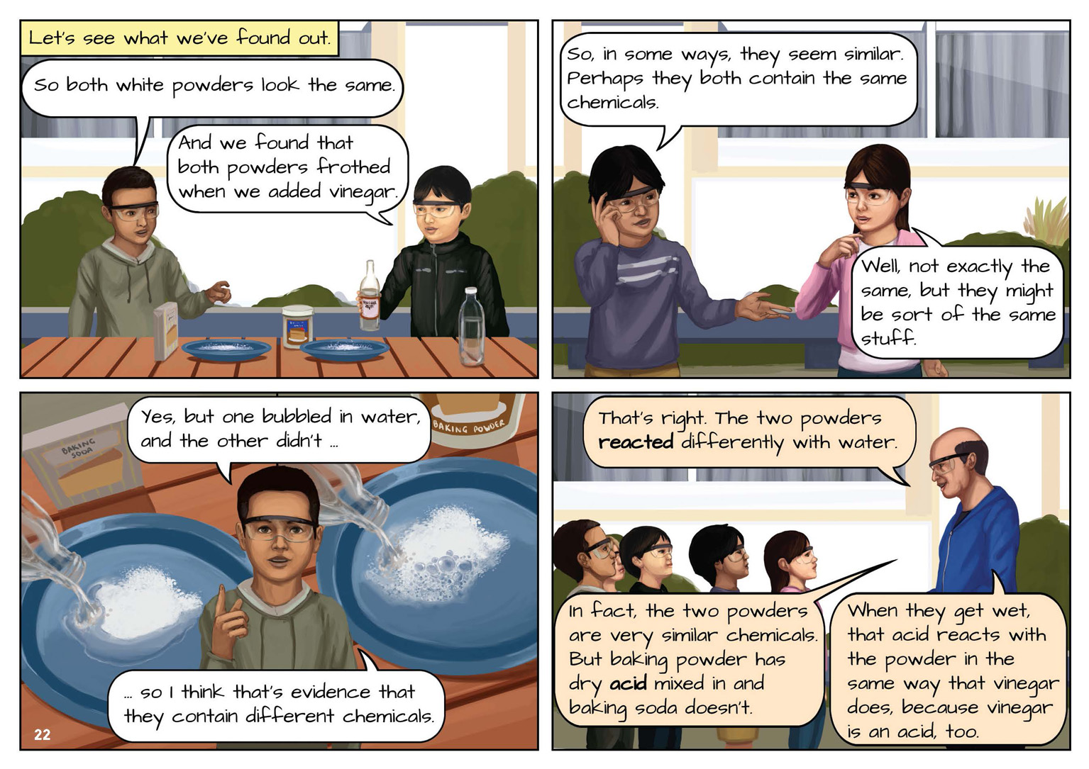 | Students extend their experiences and personal explanations through exploration.  Students observe, describe, and compare chemical properties of common materials.  Observations provide evidence that can be used to support or revise ideas.  Students extend their experiences and personal explanations through exploration.  Changes can occur when materials are mixed.
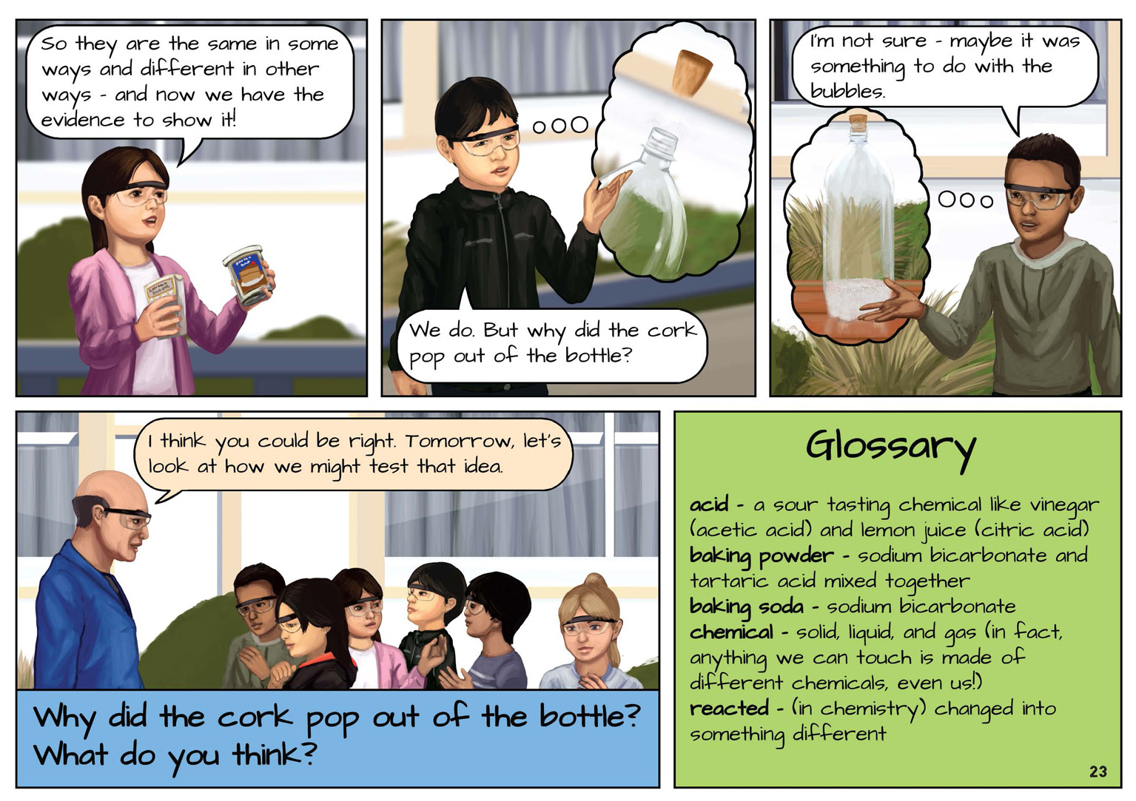 | Scientific ideas and explanations are supported by evidence.  When a chemical change takes place, new substances are formed from those that were there at the start.  Scientists use evidence to support or revise their predictions and explanations.

Exploring the science
Some activities focus directly on the science capability of “using evidence to support ideas” and the “Nature of Science” strand. Other activities extend student content knowledge. You are encouraged to adapt these activities to make the focus on “Nature of Science” explicit and to support students to develop the capability of using evidence to support ideas.

LEARNING FOCUS
Students use evidence from their observations to support their ideas.

LEARNING ACTIVITIES

Activity 1: Following instructions
Having made a set of instructions during the reading, the students can follow the steps to recreate the experiment. You will need to work with them to build evidence for the presence of gas. Focus the students' attention on the bubbles that form (the fizzing and foaming) when baking soda and vinegar are mixed. Ask questions, such as:
What do you think is inside the bubbles?
Where do you think they have come from?
What makes you think that?
Have you seen something behave like this before?
Have the students write a report describing what they see, what they think is happening, and why.

Activity 2: Fizzing and foaming
“Chemical Popguns” on Science Online (http://scienceonline.tki.org.nz/Introducing-five-science-capabilities/Use-evidence/Chemical-popguns) demonstrates how you can use the activities described in the Making Better Sense of the Material World unit “Fizzing and Foaming” to allow students to strengthen their use of evidence to support ideas. It suggests adaptations, what you should be looking for, and the questions you might ask to prompt scientific thinking.
The “Fizzing and Foaming” unit describes four investigations into acid-carbonate reactions:
Activity 5: “Hey, Look, the Bubbles Do Push the Boat!”
Activity 6: Catastrophic Currants
Activity 7: Make Your Own Fire Extinguisher
Investigation 1: Billowing Balloons (see Activity 3 on page 7).
Before conducting the investigations, ask the students, “What do you think will happen? Why?” Record their ideas as concept cartoons (see the link on page 2). Afterwards ask, “Did the evidence support your ideas?”
Extension
Throwing Balloons 2 (PW 2548), from the Assessment Resource Bank (http://arb.nzcer.org.nz/new_science.php), focuses on asking students to justify their ideas using the Predict, Observe, Explain strategy. The Science Online resource suggests this could be left as it is or simplified using the questions described for Chemical Popguns.

Activity 3: Billowing balloons
Conduct the “Billowing Balloons” investigation from the “Fizzing and Foaming” unit in Making Better Sense of the Material World. In this activity, students attach a balloon to a bottle that contains vinegar and baking soda. Encourage them to ask questions and investigate possible solutions:
What makes the balloon blow up?
Where has this gas come from?
Was the gas there before the reaction between the baking soda and vinegar?
What do you think will happen if we add more baking soda? Why?
What if we add more vinegar?
What might happen if we added more and more of both? Why?

Activity 4: Film canister rockets
In the Science Learning Hub activity “Film canister rockets” (www.sciencelearn.org.nz/Contexts/Rockets/ Teaching-and-Learning-Approaches/Film-canister-rockets), students make rockets using film canisters, baking soda, and vinegar. They develop their understanding of rocket propulsion and investigate the amount of vinegar that will make the rocket go the highest. This activity is an ideal way to demonstrate the Nature of Science. Success depends on identifying all of the variables that might affect the results; in this case, the height that is reached. Only one variable should be changed for each trial.
Note: This activity requires a white film canister for each pair of students. These can be obtained from photo shops although they are becoming scarcer, so keep your supply for future investigations.
Google Slides version of “Pop! Froth! Fizz!” www.connected.tki.org.nz

RESOURCE LINKS

“Chemical Popguns” from Science Online
http://scienceonline.tki.org.nz/Introducing-five-science-capabilities/Use-evidence/Chemical-popguns
“Film canister rockets” from the Science Learning Hub
www.sciencelearn.org.nz/Contexts/Rockets/Teaching-and-Learning-Approaches/Film-canister-rockets
“Fizzing and Foaming” in Making Better Sense of the Material World, pp 74–83.
“Throwing Balloons 2 (PW 2548)” from the Assessment Resource Bank
http://arb.nzcer.org.nz/new_science.php

