CONNECTED, LEVEL 2 2013, I Spy …  Look out for Monarchs  by Bob Brockie  Overview  This article describes what scientists are doing to find out about the distances butterflies fly and where they go in winter.  It explains what citizen scientists can do to help biologists and ecologists make observations and collect data.  A Google Slides version of this article is available at www.connected.tki.org.nz. |  |  |  |  | 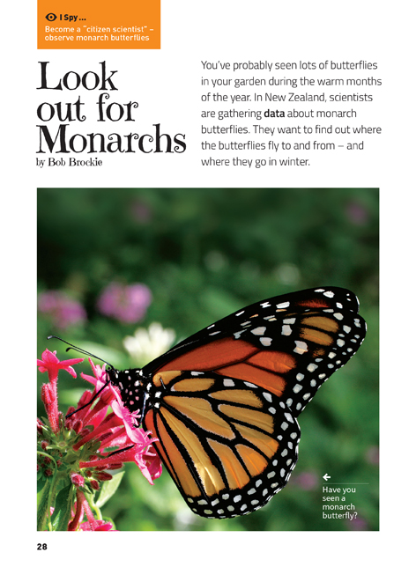
Science capability  Students need to develop a set of capabilities that support them to ask informed questions if they are to participate as “critical, informed, responsible citizens in a society in which science plays a significant role”. The capabilities enable students to meet the achievement objectives in a way that supports the purpose of science in The New Zealand Curriculum and the development of the key competencies. These capabilities include being ready, willing, and able to gather and interpret data. Students need to understand what counts as evidence in science, the importance of observation, and the difference between observation and inference. |  |  |  | Text characteristics  - Photographs and diagrams that clarify the text and require some interpretation  - Scientific and technological vocabulary that may be unfamiliar to some students  - The mathematical concept of time  - Conversational tone that includes direct address to the reader.

Curriculum context

SCIENCE
NATURE OF SCIENCE: Investigating in science  Achievement objective(s)  L2: Students will extend their experiences and personal explanations of the natural world through exploration, play, asking questions, and discussing simple models. |  | LIVING WORLD: Ecology  Achievement objective(s)  L2: Students will recognise that living things are suited to their particular habitat.  LIVING WORLD: Evolution  Achievement objective(s)  L2: Students will recognise that there are lots of different living things in the world and that they can be grouped in different ways. |  |  |  |  | Key Nature of Science ideas  - Science knowledge is based on direct, or indirect, observations of the natural physical world.  - Scientists gather data using their senses to make observations.  - Making careful observation often involves measuring something.  - Observations are influenced by what you already know.  Key science ideas  - Insects are animals too.  - All types of animals produce young so the species can keep going.  - Some babies go through different stages before they reach adulthood.  - Different species have different responses to seasonal changes in order to survive.

ENGLISH
READING  Ideas  L2: Students will show some understanding of ideas within, across, and beyond texts. |  | INDICATORS  - Uses their personal experience and world and literacy knowledge to make meaning from texts.  - Makes meaning of increasingly complex texts by identifying main ideas.  - Makes and supports inferences from texts with some independence. |  |  |  | THE LITERACY LEARNING PROGRESSIONS  The literacy knowledge and skills that students need to draw on by the end of year 4 are described in The Literacy Learning Progressions.

Scientific investigation
A science investigation where you change or try something and observe what happens is called an experiment. Not all scientific investigations are experiments; there are many ways of investigating in science. The New Zealand Curriculum science achievement aims indicate that students should experience a range of approaches to scientific investigation including classifying and identifying, pattern seeking, exploring, investigating models, fair testing, making things, and developing systems. Many scientific investigations involve systematic observation over time of an object, an event, a living thing, or a place.  Some important things to remember when you do a scientific investigation are: to be systematic and fair; to make sure that only one thing is changed at a time if you are doing an experiment or fair test so you are sure which changes result in which outcome; to observe and record what happens very carefully; and to be open minded so you notice things you are not expecting. |  |  |  | Sound data is obtained when you are able to get similar outcomes each time you do the same thing, or when data has been collected in the same way and in a systematic manner. No investigation or experiment results in a “wrong” outcome. You may have done something differently from others or the conditions may be slightly different so you don’t get the same result as others do, but it is not “wrong”.  Thinking about and developing explanations about why things happen the way they do, based on evidence, is an important aspect of science. Another important aspect is critically evaluating methods and ideas. Part of a scientist’s work is critiquing and evaluating the methods and ideas of other scientists. They expect their work to be subject to critique. If they are going to be able to make informed decisions about scientific issues as responsible citizens, students first need to experience a range of approaches to scientific investigation and to practise critique and evaluation of scientific methods and ideas – both their own and those of others – just like scientists do!

Meeting the literacy challenges

The following strategies will support students to understand, respond to, and think critically about the information and ideas in the text. After reading the text, support students to explore the key science and technology ideas outlined in the following pages.  TEXT CHARACTERISTICS  - Photographs and diagrams that clarify the text and require some interpretation  - Scientific and technological vocabulary that may be unfamiliar to some students  - The mathematical concept of time  - Conversational tone that includes direct address to the reader. |  | TEACHER SUPPORT  Want to know more about instructional strategies? Go to:  http://literacyonline.tki.org.nz/Literacy-Online/Teacher-needs/Pedagogy/Reading#Years1-4  http://literacyonline.tki.org.nz/Literacy-Online/Teacher-needs/Pedagogy/Reading#Years5-8  http://literacyonline.tki.org.nz/Literacy-Online/Student-needs/National-Standards-Reading-and-Writing  http://www.literacyprogressions.tki.org.nz/  “Working with Comprehension Strategies” (Chapter 5) from Teaching Reading Comprehension (Davis, 2007) gives comprehensive guidance for explicit strategy instruction in years 4–8.  Teaching Reading Comprehension Strategies: A Practical Classroom Guide (Cameron, 2009) provides information, resources, and tools for comprehension strategy instruction.

INSTRUCTIONAL STRATEGIES
FINDING THE MAIN IDEAS  Ask questions to orient the students to the text.  - What do you know about monarch butterflies? What do you know about their life cycle? Can you draw a quick sketch?  - How do you think you could help the biologists and ecologists?  - Why might scientists want to find out where monarch butterflies fly to and from – and where they go in winter?  - How might they find this out?  RECORD the students’ predictions and PROMPT them to read on to find out whether they were correct.  ASK the students to work out how far the tagged monarch butterfly had flown each day.  - What does this tell you about the monarch butterfly?  When they have finished reading, have the students COMPARE their predictions to what they discovered.  ASK QUESTIONS to help the students to consider the author’s purpose, whether it was achieved, and how.  - What does the author want the reader to do?  - How does the author try to do this?  - Why are these strategies successful?  - Has he achieved his purpose?  - What other strategies could the author use? |  | USING DIAGRAMS TO CLARIFY THE TEXT  Explain how the diagram on page 29 shows the life cycle of the monarch butterfly. Ask the students to compare the diagram with the sketches they drew earlier.  - What, if anything, have you learned that is new?  Use the diagram to address the common misconception that students may have – that the caterpillar and butterfly are not the same individual. Even though they look different, they are still the same insect. Explain that larval forms are in fact insects, even though they don’t have six legs and three body parts. It is just that they are in a juvenile form.  Look closely at the photographs of the butterflies. MODEL by thinking aloud how the photograph provides visual support for the text.  - I’ve been wondering how the tags are placed without damaging the butterfly’s wings or affecting its flight. Looking at the photograph on page 31, I can now see that the tags don’t interfere with the wings in the way I thought they might.  DISCUSS the form on page 32 and ASK QUESTIONS that draw out the importance of having a standard way of collecting data.  - Why do you suppose the scientists want everybody to fill out the same form instead of just writing to them?  - Why do you think they need each of these pieces of information?  DEALING WITH UNFAMILIAR VOCABULARY  PROMPT the students to use the glossary to find the meaning of words in the text.  DISCUSS the similarities and differences between the words “ecologist” and “biologist”. Together, with the students, look up the meanings of the suffix “-logy” (someone who studies a certain field) and the prefixes “eco-” (the environment, habitat, or surroundings) and “bio-” (life).  - Can you think of other words that use those parts? What do you think they mean?  Have the students IDENTIFY and DISCUSS the different terms for a monarch butterfly.  EXPLORE the ideas that not all Māori use the term “kahuku” for monarch butterflies and that there are many caterpillar terms in Māori.  EXPLORE the meaning of the word “overwintering” using the clues within and around the word.  PROMPT the students to notice the way the words “larva” and “pupa” are made plural by the addition of an “e”.  DISCUSS the concept of a “citizen scientist”, linking this to what the students may have learned in social studies about the concept of citizenship.

Teacher support
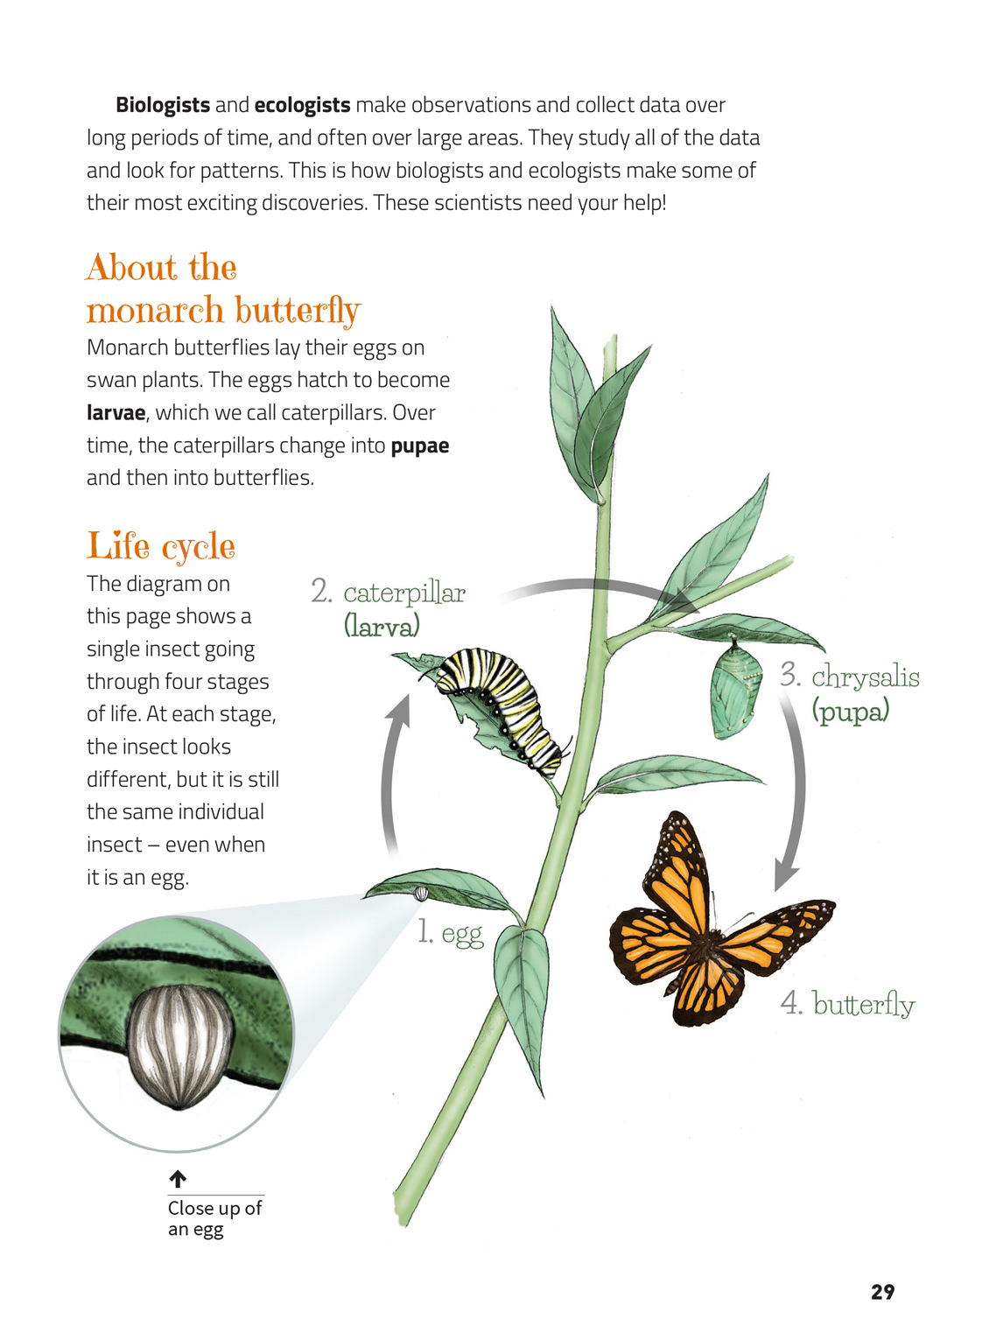 | Make observations over time to look for patterns and trends.  All types of animals, including insects, produce young so that the species can keep going.  Some babies go through different stages before they reach adulthood.  Scientists gather data using careful observations.
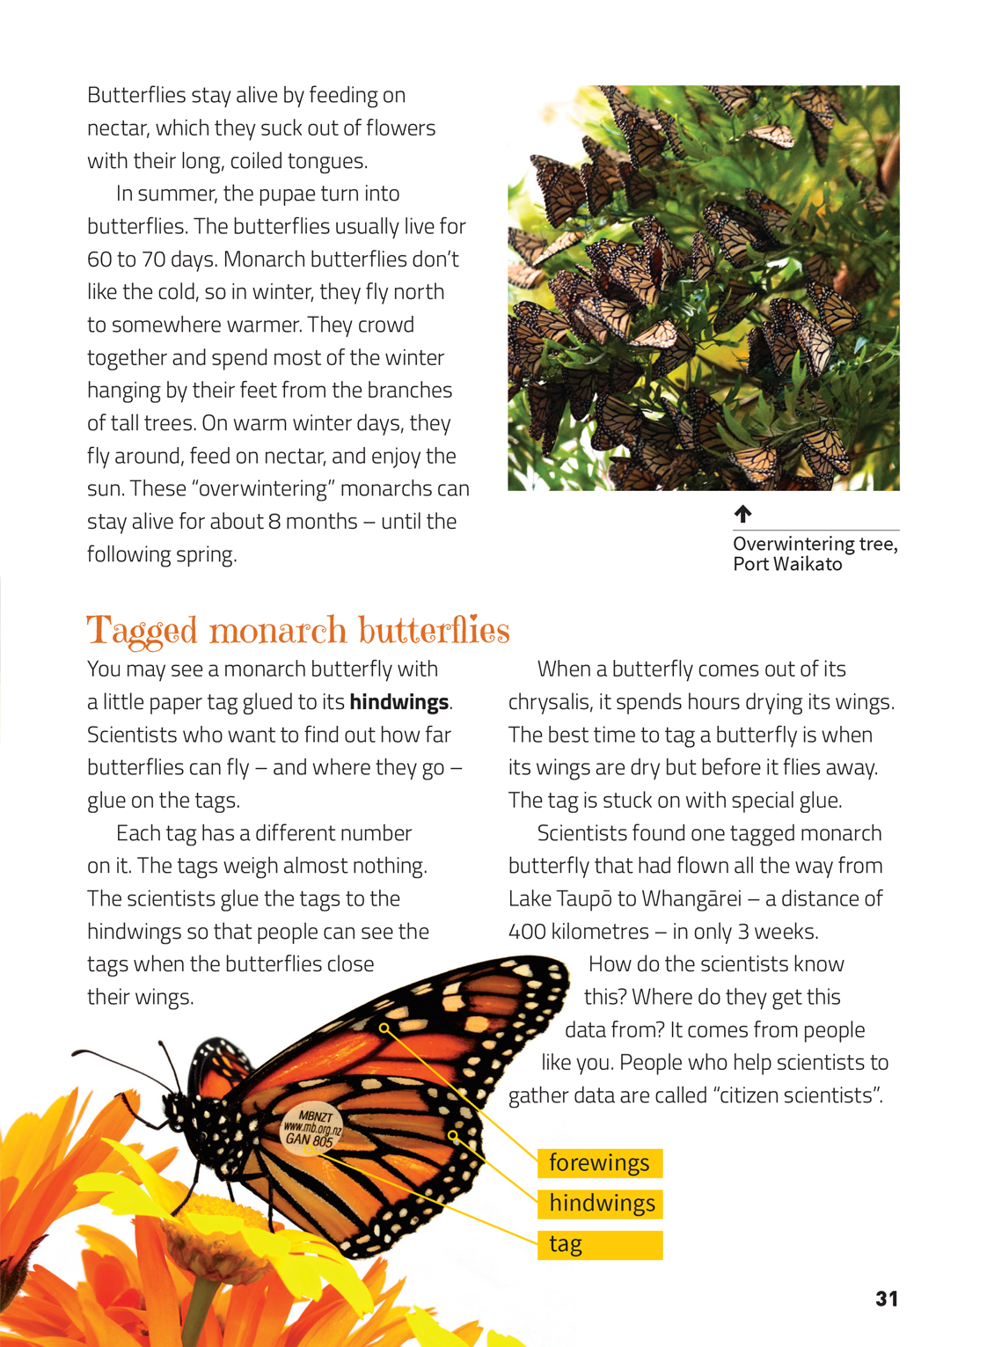 | Science is collaborative. Scientists work with other people to help gather data.  Scientists use their prior knowledge to find the best time to tag butterflies.  Making careful observations often involves measuring something.  Different species have different responses to seasonal changes in order to survive.

Exploring the science
Some activities focus directly on the science capability of “gathering and interpreting data” and the Nature of Science strand. Other activities extend student content knowledge. You are encouraged to adapt these activities to make the focus on Nature of Science explicit and to support students to develop the capability to collect and interpret data.
LEARNING FOCUS |  | KEY SCIENCE IDEAS
Students make observations, gather data, and interpret and discuss outcomes based on their observations. |  | Key Nature of Science ideas  - Science knowledge is based on direct, or indirect, observations of the natural physical world.  - Scientists gather data using their senses to make observations.  - Making careful observation often involves measuring something.  - Observations are influenced by what you already know.  Key science ideas  - Insects are animals too.  - All types of animals produce young so the species can keep going.  - Some babies go through different stages before they reach adulthood.  - Different species have different responses to seasonal changes in order to survive.

LEARNING ACTIVITIES

Activity 1: Constructing a habitat
The students could design a “butterfly garden”, either outside or using pot plants inside. They would need to begin by researching the kinds of plants that attract butterflies. Depending on their availability, they could then populate a plant with caterpillars or chrysalises.
The students can then observe and record the life cycle changes from egg to larva to pupa to adult. They could use photographs or sketches to collect their data, carefully dating it and using scientific language to identify the stages and describe what they see. They could make close observations of particular aspects, for example, the amount the caterpillars eat and the rapidity of their growth.
Note that if pot plants are used, the hatched butterflies would need to be released after the cycle is complete.
For an example and helpful information, see the links to information about the butterfly garden at Muritai School.

Extension
Use Building Science Concepts Book 4 Animal Life Histories to extend the students’ understandings about the process of growth and change that all animals undergo in their journey from fertilised egg to adulthood.
The big ideas most relevant to this level are that:
reproduction is the most important activity for the survival of a species
various features change at different parts of the life history to contribute to reproductive success.
There are Assessment Resource Bank Activities you can use to help you assess the students’ understanding of these concepts.

Activity 2: Observing butterflies
Have the students collect data about the type and number of butterflies, birds, or insects observed in their school, at home, or at a local reserve. (This could be done before and after the introduction of a school butterfly garden to investigate its effect). Decide as a group what information would be useful to know, and why (for example, type of insect, time seen, and location). The students could design and use a form similar to the one mentioned in the article in Connected.
Ask questions to help the students interpret their data, for example:
Are there patterns in the data?
Are some kinds more common in certain kinds of weather? On certain types of plant?
Are some seen more often before school than at lunchtime? Or in particular places?
What might cause these patterns? What evidence is there for possible explanations?
Prompt the students to ask their own questions about the data.

Activity 3: Moths and butterflies – what’s the difference?
Have the students look at photographs showing a range of species of moths and butterflies. (There is a helpful collection on the TERRAIN site.) Ask them to look carefully to identify similarities and differences between moths and butterflies. They can then produce a PowerPoint using photos and diagrams to show someone in another class what to look for to differentiate between the two.
Explore the behaviours of moths and butterflies and consider how these help them to stay alive. Are there moths that come out in daytime? Are there butterflies that fly at night?

Activity 4: Responding to seasonal change
Use the article on overwintering sites in Issue 5 of Butterflies and Moths of New Zealand to find out more about how monarch butterflies cope with cold weather. Then use Building Science Concepts Book 44 to find out about how other insects, animals, and plants respond to seasonal changes. Section 3, Activity 2 in Book 44 on page 14 is particularly relevant, as it involves groups of students conducting research into bird migration.

Activity 5: Taking action: become a citizen scientist
Use the Science Learning Hub link on citizen scientists to further explore this concept and to find out about citizen science in action. The site has several articles on this topic, as well as two teaching and learning activities: one on establishing butterfly transects and one on tagging monarch butterflies for science.
The students may be interested in becoming involved in citizen science projects in their local community. They may want to pick up the idea of volunteering for the Monarch Butterfly New Zealand Trust, as suggested in the article.
Two other options are Project Crimson and the National Garden Bird Survey.
Project Crimson is a conservation project focused on re-establishing the pōhutukawa and rātā. Schools can get involved in the Treemendous School makeover project, working with their community to create interactive learning spaces.
The National Garden Bird Survey is led by Landcare Research and takes place annually in the first week of July. A survey form and bird identification chart is provided. Participants spend an hour observing the birds in their garden and recording the highest number that they see or hear at one time. The survey results are used to create a picture of how birds are faring in New Zealand gardens. Progress results can be accessed from the Landcare Research sites so that students can also see the results as they come in and ponder the patterns they see.

Activity 6: Further reading
Moths and butterflies are popular topics with both authors and students. These include:
“The Luck of the Draught” Connected 3, 2001
“By Wing and Wind” Connected 3, 2001
“Tag and Release” SJ 2.4.09
Google Slides version of “Look out for Monarchs” www.connected.tki.org.nz

RESOURCE LINKS

Building Science Concepts, Book 4 – Animal Life Histories
Building Science Concepts, Book 44 – Spring is a Season: How Living Things Respond to Seasonal Changes
Which New Zealand Insect? (Penguin, 2002) – See page 4 for caterpillar terms in te reo Māori.
Science Online www.scienceonline.tki.org.nz
Science Learning Hub www.sciencelearn.org.nz/Science-Stories/Butterflies/Tagging-monarch-butterflies-for-science
Science Learning Hub http://www.sciencelearn.org.nz/Science-Stories/Butterflies/Citizen-scientists
Science Learning Hub http://www.sciencelearn.org.nz/Science-Stories/Butterflies/Differences-between-butterflies-and-moths
Learnz: Interactive life cycle http://www.learnz.org.nz
Assessment Resource Banks http://arb.nzcer.org.nz/ (LW 1056, LW 1057)
YouTube video: How to tag a butterfly http://www.youtube.com/watch?v=sQtMEulY_D4
Monarch Butterfly New Zealand Trust www.monarch.org.nz
Muritai School YouTube video http://www.schooltube.com/video/332e631dc8034a16bd35/Butterfly%20Garden
“Muritai School, Eastbourne Enjoys the Benefits of Butterflies”, Butterflies and Moths of New Zealand, Issue 5, Winter 2013
http://www.monarch.org.nz/monarch/wp-content/uploads/2013/06/Winter-2013-for-web.pdf
TERRAIN: Butterflies and Moths http://www.terrain.net.nz/friends-of-te-henui-group/local-butterflies-moths.html
Project Crimson (saving the rātā) http://www.projectcrimson.org.nz/home/page.aspx
Learnz http://www2.learnz.org.nz/core-fieldtrips.php
National Garden Bird Survey http://www.landcareresearch.co.nz/science/plants-animals-fungi/animals/birds/garden-bird-surveys/instructions
Kiwis for Kiwi Trust http://www.kiwisforkiwi.org/take-action/schools/

